ISSUES ON NSIRS PROJECT

**Monthly Payroll**

* The logo and header should be bold, the one on the system is looking small and the column should be adjusted/align, the serial number column is wide and other column that is wide should be adjusted.
* On the print page somethings are left out, the complete column should show and each page should carry the header.
* On the header the arrears should come before Gross, it should be arranged in their format, Basic, Hazard, Dressing, Transport, Special, Arrears, and Gross Pay.

**On the Deduction**

* DEDCTLS is appear twice, DEDCTLS should be replaced to CTLS, DEDRENT to RENT because they are all under deductions.
* The column should be arranged in their format to make it easy for them.
* The NASARAWA STATE GOVERNMENT should be bold, and arrange is separated

**Salary Analysis**

* The analysis is supposed to pick the July gross pay and August gross pay, the difference is supposed to show if it increased or decreased, if it creases that means the allowance the paid, either there is a promotion that was paid, or a new staff joined, that is why the add function is there.

**Periodic**

* Mr. Tunde said Mr. Godwin and Mr. Joey Promised him that the periodic will be ready by next week.
* The system retired an employee, and he can’t view it from the dashboard, he can’t view the employ’s details to find out what the problem is.
* He required that the items on the dashboard should be clickable.

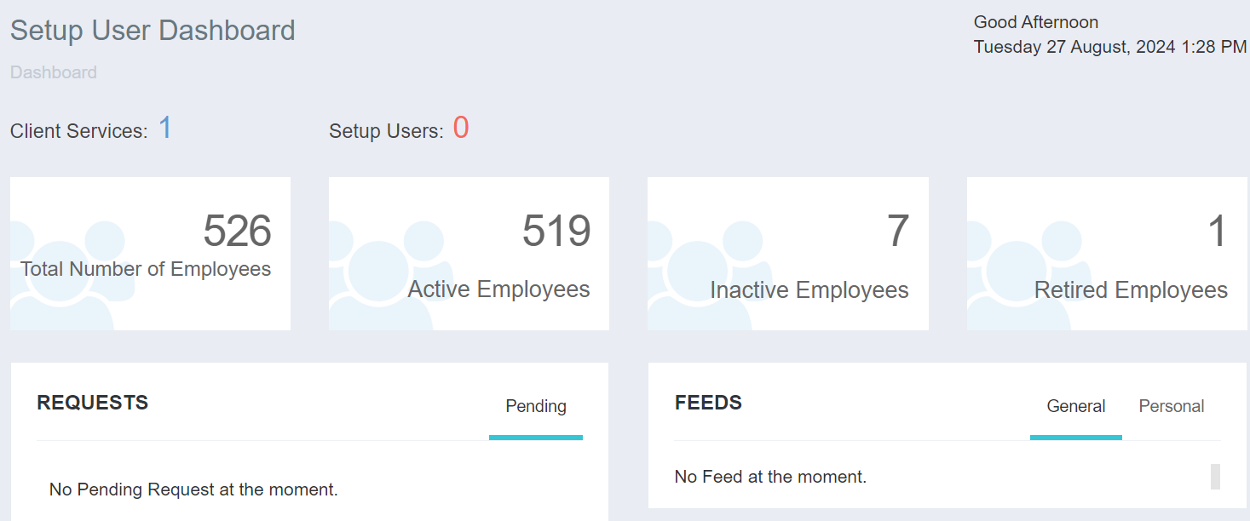

ON THE AUTORIZATION BOARD

* The transactions that are waiting for approval should be on the authorized board.
* When there is a change of name or change of account number there should be an approval
* He talked about the users and their roles.